What is IQ?
intelligence quotient:
* a measure of a person's intelligence (the ability to think and reason) as indicated by an intelligence test
* the ratio of a person's mental age to their chronological age (multiplied by 100)
wordnetweb.princeton.edu/perl/webwn
http://www.free-iqtest.net/

Example: Imagine your “mental age” is 25 and your chronological age is 12.
25/12 X 100= 208 WHOAH! Genius!
Imagine your “mental age” is 6, but your chronological age is 12.
6/12 X 100 = 50
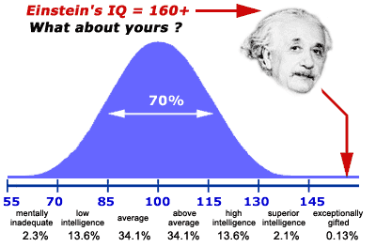
Intelligence Interval | Cognitive Designation
40 - 54 | Severely challenged (Less than 1% of test takers)
55 - 69 | Challenged (2.3% of test takers)
70 - 84 | Below average
85 - 114 | Average (68% of test takers)
115 - 129 | Above average
130 - 144 | Gifted (2.3% of test takers)
145 - 159 | Genius (Less than 1% of test takers)
160 - 175 | Extraordinary genius

IQ Societies: Could you be a member?
MENSA | Mensa is the largest, oldest, and best-known high-IQ society in the world. The organization restricts its membership to people with high testable IQs. Specifically, potential members must score within the top 2% (at or above the 98th percentile) of any approved standardized intelligence test.[
The Pars Society | Pars Society was founded in 2002 by Baran Yönter as a high intelligence society.
The Giga Society | The Giga society is the world's most exclusive High-IQ society. At least this is the case if you make "having one or more members" a part of the definition of "society". An IQ of 196 or higher is required to join.
The Sigma Society | Sigma Society is an organization of international scope.
International High IQ Society | The 2nd largest high-IQ organisation in the world. Membership in the International High IQ Society is open to persons who have an IQ in the top five percent of the population and who want to be part of our global community. There is no other qualification for membership.
The Mega Foundation | The Mega Foundation is a tax-exempt non-profit charitable organization established to create and implement programs that aid in the development of severely gifted individuals and their ideas. The Mega Foundation also supports and develops innovative projects, in the arts and sciences, based solely upon the merit of the projects and the vision of their creators.
The Cerebals Society | Cerebrals Society is an international society for people who have a documented IQ score of at least 144 sd16 from standardized, professional tests of intelligence only. This means that membership is open for the top 0.3% of people along the IQ spectrum.
The Prometheus Society | The Prometheus Society was established in 1982 by philosopher Ronald K. Hoeflin, Ph.D. (see picture) to promote fellowship among individuals with extremely high intelligence.
Mysterium | Mysterium is not just another high IQ society. Mysterium is not something you join, receive a certificate to hang on the wall, then vegetate. Mysterium is not for the "average genius" with a pocket full of ideals and nothing to show for it. Mysterium is beyond outer space, inner space, and cyberspace. Mysterium is a nurturing, stimulating, and inspiring "growth link" to human creativity, ingenuity, and originality that is undergirded by experience and productivity.
The Triple Nine Society | The Triple Nine Society is committed to friendship, communication, the adventure of intellectual exploration, and a greater realization of individual potentials. It neither sanctions the imposition of one person's philosophy on another nor subscribes to any particular philosophy for its members.

